**ParQ - The Parking Finder App**

   
 

Submitted by: Group 1

Submitted to:   George Kougioumtzoglou

ICET Department,

School of Engineering Technology and Applied Science

Progress Campus, Block A

Centennial College

Discipline:   Software Engineering 

Due Date: October 3, 2021

# 

# 

# 

# Declaration of Sole Authorship

We, Group 1, confirm that this work submitted for assessment is our own and is expressed in our own words. Any uses made within it of the works of any other author, in any form (ideas, equations, figures, texts, tables, programs), are properly acknowledged at the point of use. A list of the references used is included.

Signed:

* Mustafa Butt | 822392403 | Health Informatics Technology
* Emmanuel Ajayi | 301050676 | Game Programming
* Sanjib Saha | 301100387 | Software Engineering Technology
* Shaminda Abeysekara | 301056885 | Software Engineering Technology
* Gai Huang | 300945908 | Game Programming
* Basanta Babu Ghimire | 300947690 | Software Engineering Technology
* Shaniquo McKenzie | 301024574 | Health Informatics Technology
* Ibrahim Jomaa | 300911528 | Software Engineering Technology

 Date: October 3, 2021

# Abstract

This document gives an accurate description of the ParQ mobile application along with the technical requirements and business logic. It will be used as a roadmap and reference for the developer and the customer team in the creation of the software. This document contains the necessary diagrams, stories, and documentation for a successful project.

**Table of Contents**

**Declaration of Sole Authorship** **2**

**Abstract** **3**

**List of Tables** **5**

**1.0 INTRODUCTION** **6**

**2.0 METHODOLOGY AND RESULTS** **7**

2.1 Literature Review 7

2.2 Proposed Solution 7

2.3 User Role Modelling 8

2.3.1 Brainstorm and Group 8

2.3.2 Consolidated User Roles 8

2.3.3 Description of User Roles and Persona 10

2.3.4 Additional Documentation 11

2.4 Release 1.0 12

2.4.1  User Stories 12

2.4.2  Additional Documentation 15

2.4.3  Release Plan 1.0 16

2.4.4  Iteration Plan (Release 1.0) 19

2.4.5 Additional Documentation 21

2.4.6 Progress Monitoring 22

**Progress Monitoring II** **22**

Progress & Changes Table 22

2.4.7  Acceptance Tests for Release 1.0 23

**3.0 CONCLUSIONS** **24**

**CREDITS, LICENSE, AND REFERENCES** **25**

Credits 25

License 25

References 25

**APPENDIX A (DESIGN DOCUMENT)** **26**

**APPENDIX B (TEST PLAN)** **31**

1.0 Introduction 31

1.0.1   Goals 31

1.0.2   Assumptions 31

1.0.3   Risks And Assets 32

2.0 Scope 32

2.0.1   Features To Be Tested 32

2.0.2    Features Not To Be Tested 32

3.0 Testing Procedures 33

3.0.1   Test Objectives 33

3.0.2   Types Of Testing 33

3.0.2.1   Unit Testing 33

3.0.2.2   Integration Testing 33

3.0.2.3   Acceptance Testing 33

3.0.2.4   Stress Testing 34

3.0.2.5   Performance Testing 34

3.0.3   Testing Tools 34

**APPENDIX C (END-USER & ADMINISTRATOR MANUALS)** **35**

**APPENDIX D (PROGRESS MONITORING)** **37**

**Progress Monitoring II** **37**

Progress & Changes Table 37

# List of Figure

Figure 2.3.1: Organizing the user role cards on a table [1] 9 Figure 2.3.1B: Organize the user role [1] 10 Figure 2.3.2: The consolidated role cards [1]. 11 Figure 2.4.1 - Low-Fidelity Prototype and User Stories for Driver role 13 Figure 2.4.2 - Low-Fidelity Prototype and User Stories for Parking Vendor role 14 Figure 2.4.3 Low-Fidelity Prototype and User Stories for Parking Lot Administrator role 15 Figure 2.4.4 : Driver user Estimation 16 Figure 2.4.5 : Parking Vendor user Estimation 17 Figure 2.4.6 : Admin user Estimation 18

# List of Tables

Table 2.3.1: The Description of User Roles and Persona [1] 12

Table 2.4.1: The Must-Have stories for Release 1.0. 17

Table 2.4.2: The Should-Have stories for Release 1.0. 18

Table 2.4.3: The Could-Have Stories for Release 1.0. 18

Table 2.4.4: The Won’t-Have stories for Release 1.0. 18

Table 2.4.5: Release Plan for Release 1.0. 19

Table 2.4.6: Release Plan I for Release 1.0. 20

Table 2.4.7: Release Plan II for Release 1.0. 21

Table 2.4.8: Stories, acceptance tests, and contributors for Release 1.0 24

# 1.0 INTRODUCTION

How does a driver find their ideal parking spot? Apart from the time-consuming task of driving around looking or knowing beforehand, the methods are quite limited. Even more so for drivers already on the go.

The ParQ mobile application provides drivers a convenient means of finding and browsing available parking and rates. ParQ will enable drivers to find available parking and rates with just their mobile device, rather than the traditional method of driving around in the hopes of being lucky.

The Scope Includes:

* Parking aggregation tool compiles available parking location details
* A database for registered users, registered parking vendors and admin
* Parking vendor accounts have CRUD functionality for parking locations, while admin has CRUD functionality on accounts and privileges.
* Connection to multiple parking companies’ API to get parking data
* Geolocation for finding of, and guidance to nearest parking locations

While it Excludes:

* Web Application
* Payment Processing

While ParQ will empower drivers by saving their time, it will also empower parking vendors as well. By providing a platform for parking vendors to increase their exposure, client base and traffic, ParQ will be an ecosystem that benefits drivers as it increases revenue for parking vendors.

# 2.0 METHODOLOGY AND RESULTS

## 2.1 Literature Review

A few of the existing solutions for finding parking are SpotHero, ParkingWhiz, Parker and more. While there are many solutions, most have limited coverage range. While SpotHero has the widest collection of parking data, the rest remain limited in the cities they provide coverage for.

## 2.2 Proposed Solution

“ParQ” is an app that will allow its users to know where all the parking locations are, how much availability it has at the moment, the price per hour/day and it will allow the users to reserve and ensure their spot. Benefits:

* Less time spent on finding a parking spot.
* Optimized parking spaces
* Reduces stress, traffic and pollution
* Increases the security of the user’s cars

## 2.3 User Role Modelling

### 2.3.1 Brainstorm and Group

The ParQ mobile application's software development team and the agile customer identified the significant user in the customer-led workshop (brainstorm session).

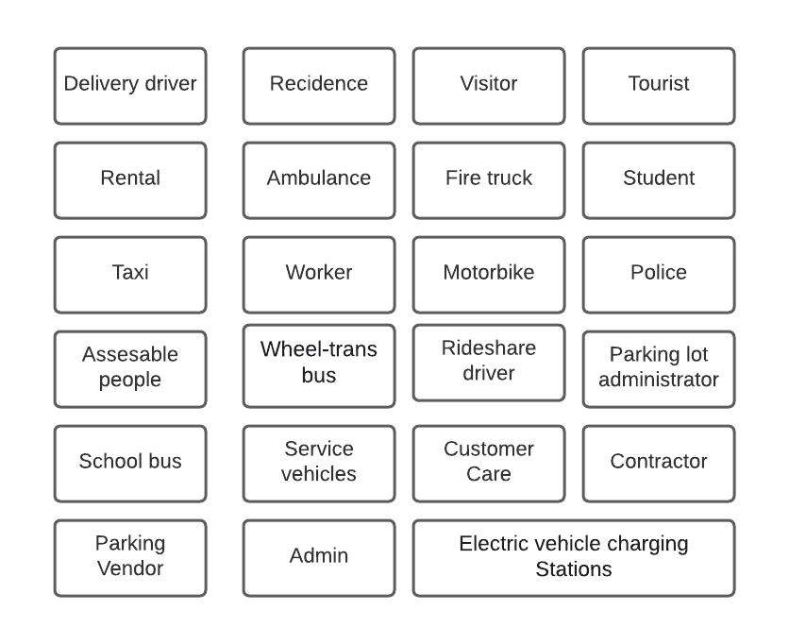

Figure 2.3.1: Organizing the user role cards on a table [1].

Classified following are the initial four groups of user roles.

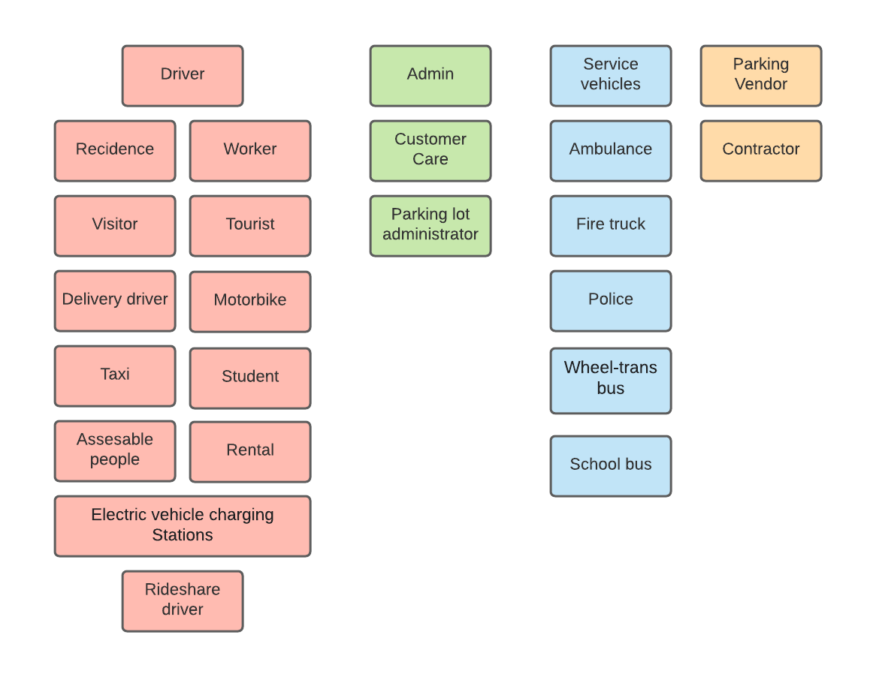

Figure 2.3.1B: Organize the user role [1].

During our brainstorm session, we, as a group, discussed the different types of users our application might have. We thought of 9 user roles that would use the application.

### 

### 2.3.2 Consolidated User Roles

In this phase of creating our user roles, we began to remove and merge some of the roles that we felt were duplicates and add some that we might have missed. So, here we have three main categories of roles: Driver, Admin and Parking Vendor.

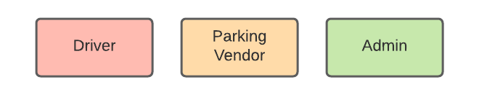

Figure 2.3.2: The consolidated role cards [1].

Driver: The driver user role contains regular users such as citizens or tourists. It is the software's primary user, so it will have a high frequency of using the software. This user role model can have medium proficiency with software due to the help provided. The driver will need to use the software to search for parking spots. The driver can search anonymously and register an account if they want exclusive features such as a pin wish parking spot, parking history, and managing profiles. This program calculates the actual time spent in the parking lot for each vehicle, so the application allows the driver to select, cancel, and reschedule reservation time. ParQ serves the user in such a dynamic way.

Parking vendor: Parking Vendors who assign parking spots and they own to apply their business. The user must have registered to use the application, and the user has a CRUD function and a payment system.

Admin: The admin user will have a high frequency of using the software and be highly proficient with the developed computer and software. The admin facilitates the service to driver and parking vendor users.

### 2.3.3 Description of User Roles and Persona

Table 2.3.1: The Description of User Roles and Persona [1]

| User role | Frequency of use of the app | Expertise with using parking services | Proficiency with computer & software | Proficiency with our application | General goal |
| --- | --- | --- | --- | --- | --- |
| Driver | High | High | low | Medium | Quality service with the best price  parking history tracking and managing  wish parking spot |
| Parking Vendor | Medium | Medium | Medium | High | assign and manage parking spots |
| Admin | High | High | High | High | Approve user (parking vendor) registration |

### 2.3.4 Additional Documentation

## 2.4 Release 1.0

### 2.4.1  User Stories

#### 2.4.1.1 Driver

| As a driver i would like to see options to sign up and log in to an account | Test by Loading application  Expected outcome:Driver is able to see both options to sign up and log in |
| --- | --- |
| As a driver i would like to sign up for a account to book parking spot | Test with wrong username.    Expected outcome: driver can’t sign up using wrong username.    Test with wrong password.    Expected outcome: driver can’t sign up using wrong password.    Test with missing username field. |
| As a driver i would like to sign in to my account portal | Test with wrong username.    Expected outcome: driver can’t sign in using wrong username.    Test with wrong password.    Expected outcome: driver can’t sign in using wrong password.    Test with missing username field. |
| As a driver i would like to update my account portal | Test by updating driver account information and test that changes have been reflected in the UI.    Expected outcome: driver will be able to make changes in the drivers account details and updated information is reflected correctly in UI. |
| As a driver i would like to search nearby parking locations | Test by searching for a nearby parking locations  Expected Outcome: Redirect to display parking locations page with search result from google API. |
| As a driver i would like to select my parking spot | Test by selecting a parking spot  Expected Outcome: Redirect to parking spot details page. |
| As a driver i would like to see my parking spot details | Test by selecting a parking spot  Expected Outcome: Redirect to parking spot details page. |
| As a driver i would like to add a parking lot to my favourite list | Test by Adding a parking lot to my favourite list  Expected Outcome:Redirects to favourite page |
| As a driver i would like to reserve a spot | Test by selecting a reserve spot.  Expected Outcome: Redirect to confirmation page |
| As a driver i would like to modify my reservation | Test by updating reserved parking spots and test that changes have been reflected in the UI.    Expected outcome: driver will be able to make changes in the reserve parking page and updated information is reflected correctly in UI. |

***Driver***

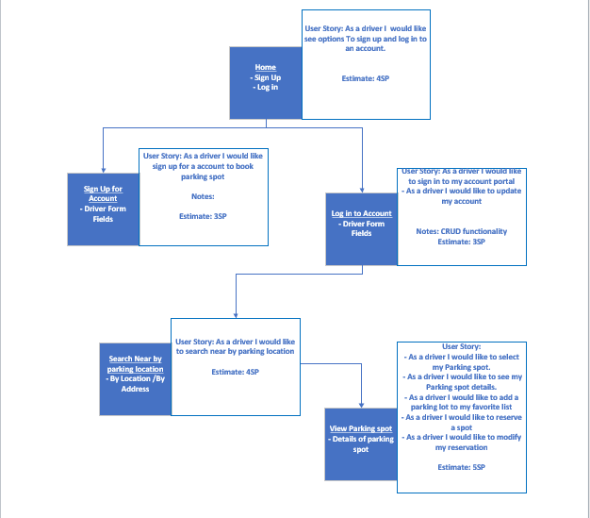

*Figure 2.4.1 - Low-Fidelity Prototype and User Stories for Driver role*

#### 2.4.1.2 Parking Vendor

| As a vendor i would like to see options to sign up and log into an account | Test by Loading application  Expected outcome:Driver is able to see both options to sign up and log in |
| --- | --- |
| As a vendor i would like to sign up for an account to promote parking services | Test with wrong username.    Expected outcome: vendor can’t sign up using wrong username.    Test with wrong password.    Expected outcome: vendor can’t sign up using wrong password.    Test with missing username field. |
| As a vendor i would like to sign into my account portal | Test with wrong username.    Expected outcome: Vendor can’t sign in using wrong username.    Test with wrong password.    Expected outcome: Vendor can’t sign in using wrong password.    Test with missing username field. |
| As a vendor i would like to update my account details | Test by updating vendor account information and test that changes have been reflected in the UI.    Expected outcome: vendor will be able to make changes in the vendor account details and updated information is reflected correctly in UI. |
| As a vendor i would like to update my parking lot details | Test by updating vendor parking lot details and test that changes have been reflected in the UI.    Expected outcome: vendor will be able to make changes in the vendor parking lot details and updated information is reflected correctly in UI. |
| As a vendor i would like to accept or decline reservation request | Test by receiving a reservation request |

***Parking Vendor***

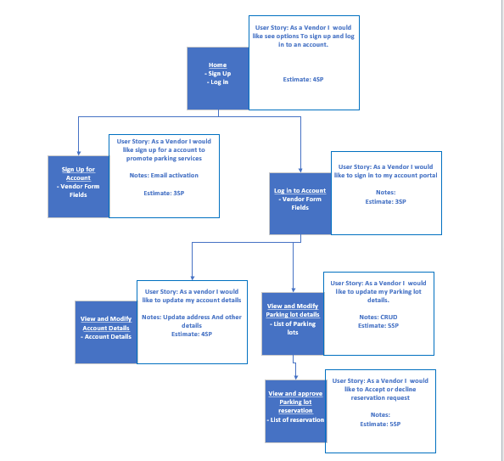

*Figure 2.4.2 - Low-Fidelity Prototype and User Stories for Parking Vendor role*

#### 2.4.1.3 Admin

| As a admin i would like to sign in and see the administrator portal | Test with wrong username.    Expected outcome: Admin can’t sign up using wrong username.    Test with wrong password.    Expected outcome: Admin can’t sign up using the wrong password.    Test with missing username field. |
| --- | --- |
| As an admin i would like to view vendors accounts and applications | Test by creating a vendor account and check that it is reflected in the vendor list.    Expected outcome: Administrator will be able to view the account lists of vendors. |
| As a admin i would like to view reservation history | Test by viewing reservation history.  Expected outcome: Returns a list of all available reservation history |
| As a admin i would like to view vendors accounts to modify accounts | Test by updating vendors account information and test that changes have been reflected in UI.    Expected outcome: Administrator will be able to make changes in the vendors account details and updated information is reflected correctly in UI. |

*Admin*

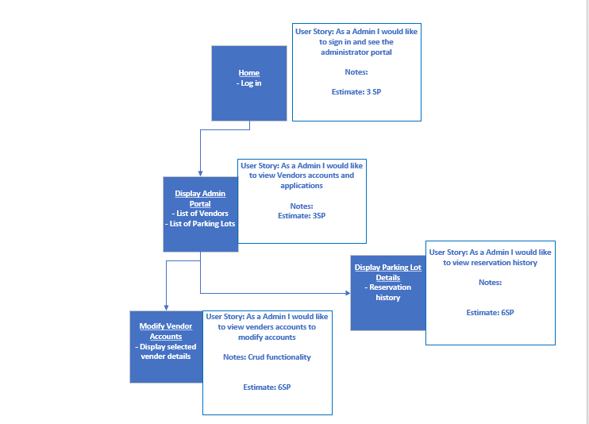

*Figure 2.4.3 - Low-Fidelity Prototype and User Stories for Parking Lot Administrator role*

### *Driver User Estimates / Triangulation Table*

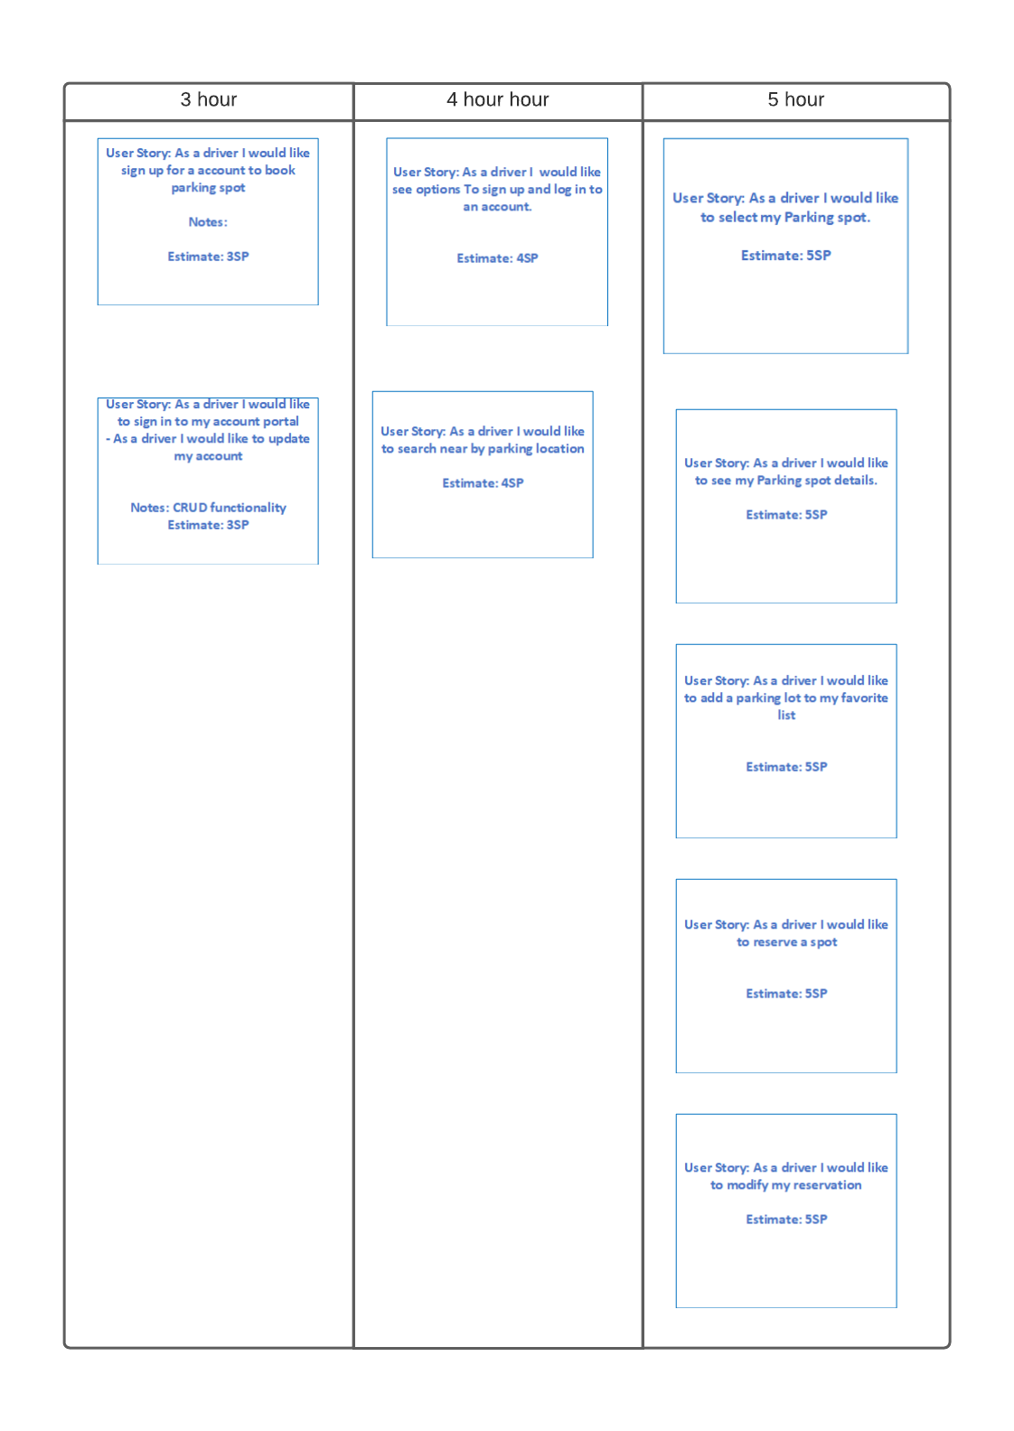

*Figure 2.4.4 : Driver user Estimation*

***Parking Vendor User Estimates / Triangulation Table***

***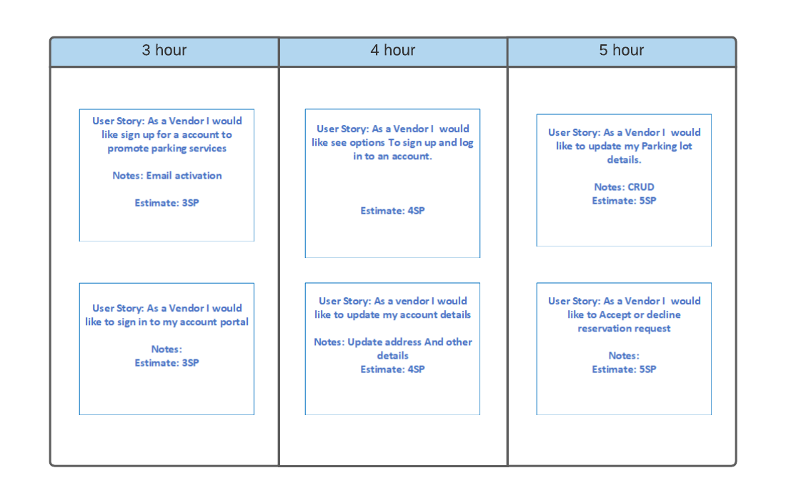****Figure 2.4.5 : Parking Vendor user Estimation*

### *Admin Vendor User EstimatesTriangulation Table*

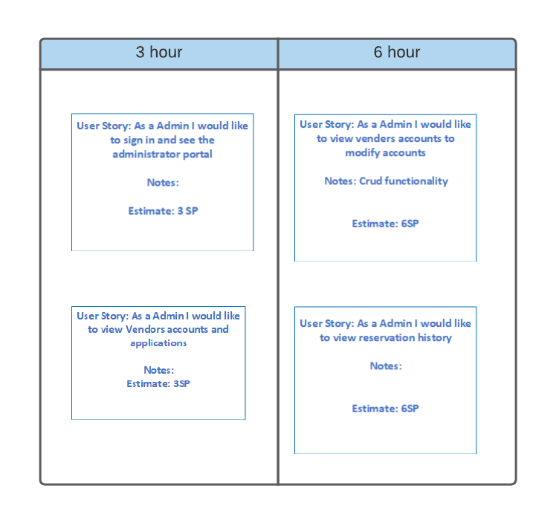

*Figure 2.4.6 : Admin user Estimation*

### 

### 2.4.2  Additional Documentation

Any additional document for ParQ will be added to this section.

#### **2.4.2.1 UI Prototypes**

##### 2.4.2.1.1 Driver

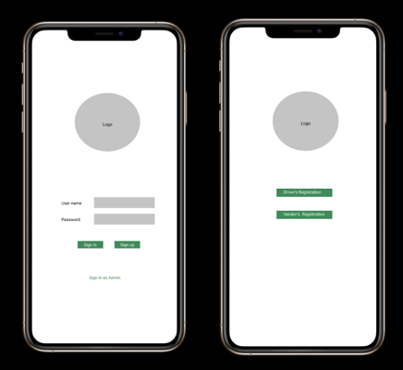

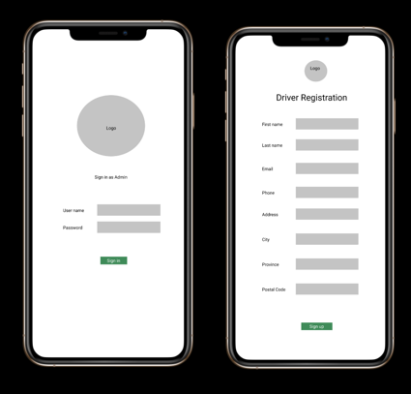

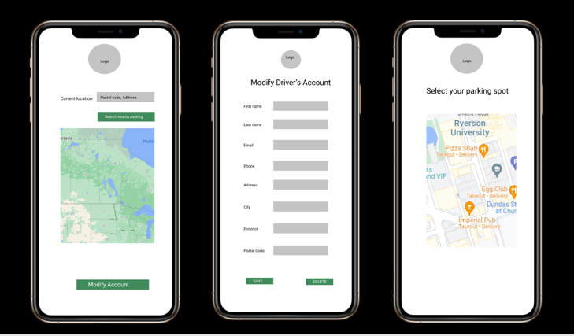

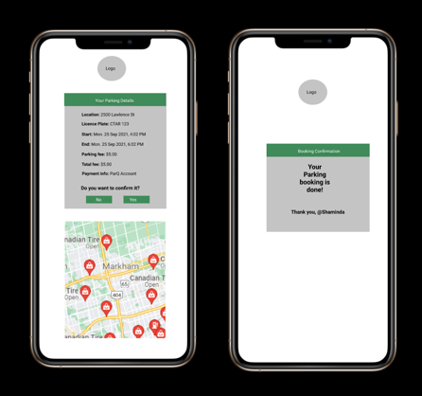

##### 2.4.2.1.2 Parking Vendor

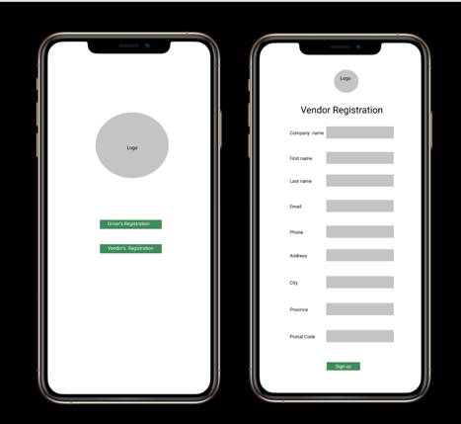

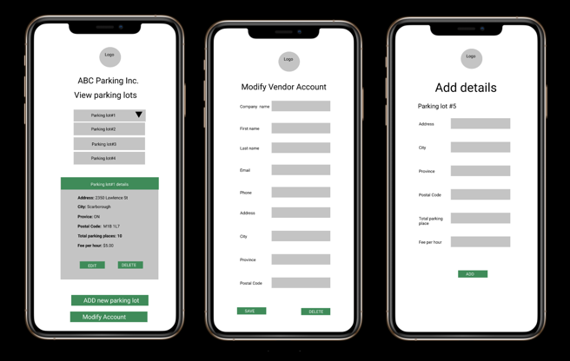

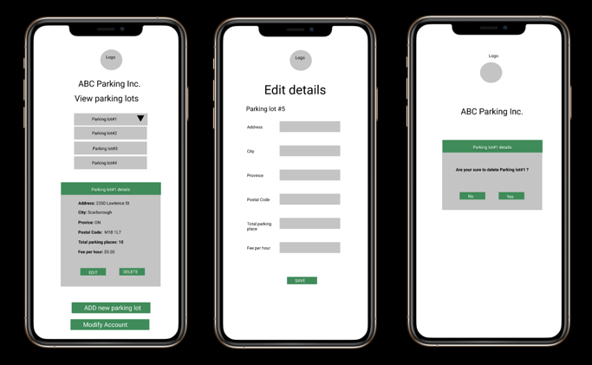

##### 2.4.2.1.3 Admin

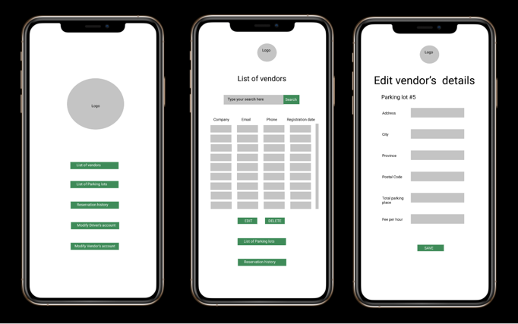

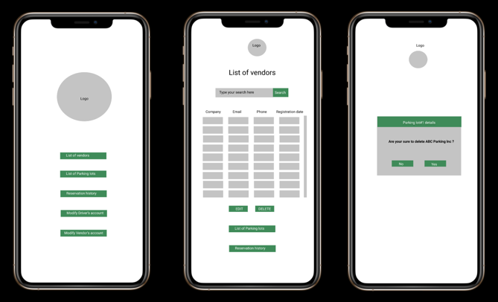

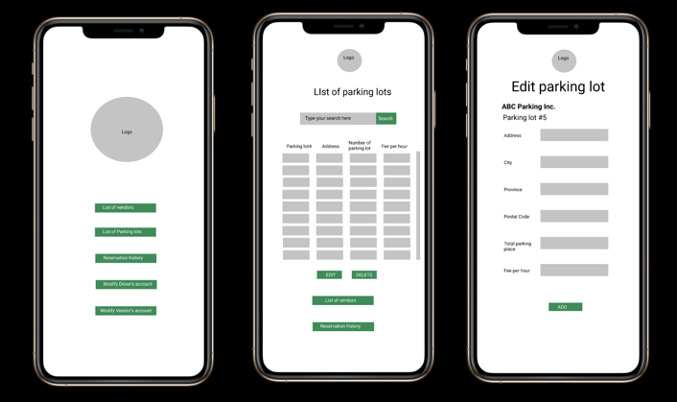

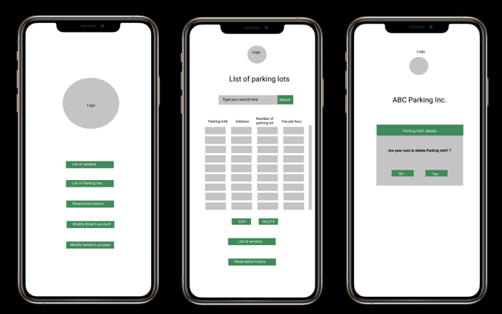

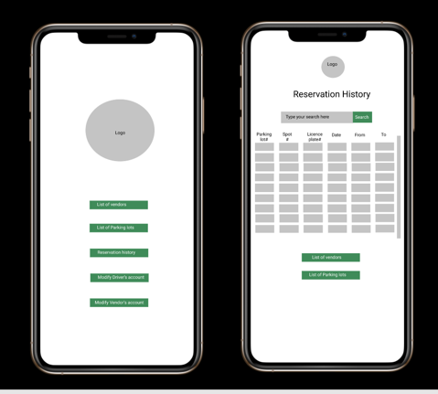

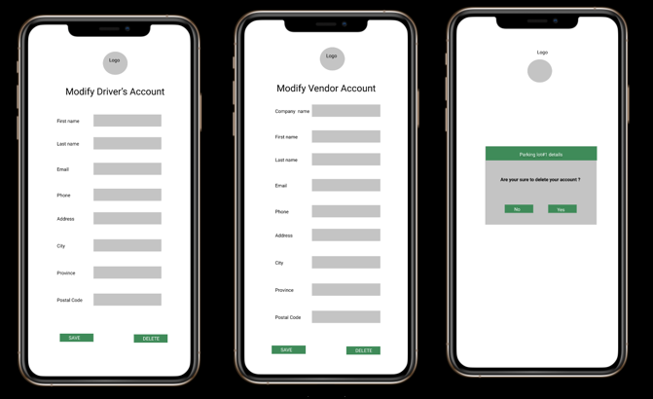

### 2.4.3  Release Plan 1.0

#### 2.4.3.1 Product Development Roadmap

1. Searching for parking spots using global parking APIs.
2. Searching and applying reservations to parkings spots hosted on ParQ’s database.
3. Parking Vendor and Admin CRUD functionality.
4. Login and Authentication services for Driver, Parking Vendor, and Admin.

#### 2.4.3.2 Product Release Plan

|  | **Start Date** | **End Date** | **Duration** | **Release Date** | **Story Points** |
| --- | --- | --- | --- | --- | --- |
| **Iteration 1** | **Oct. 18, 2021** | **Nov 14, 2021** | **28 Days** | **Nov. 7, 2021** | **107** |
| **Iteration 2** | **Nov 14, 2021** | **Dec 15, 2021** | **28 Days** | **Dec. 15, 2021** | **86** |

| **Iteration 1** | **Iteration 2** |
| --- | --- |
| **As a driver I would like to see options to sign up and log in to an account.** | As a vendor I would like to see options to sign up and log into an account. |
| **As a driver I would like to sign up for an account to book a parking spot.** | As a vendor I would like to sign up for an account to promote parking services. |
| **As a driver I would like to sign in to my account portal.** | As a vendor I would like to sign into my account portal. |
| **As a driver I would like to update my account portal.** | As a vendor I would like to update my account details. |
| **As a driver I would like to search nearby parking locations.** | As a vendor I would like to update my parking lot details. |
| **As a driver I would like to select my parking spot.** | As a vendor I would like to accept or decline reservation requests. |
| **As a driver I would like to see my parking spot details.** |  |
| **As a driver I would like to add a parking lot to my favourite list.** |  |
| **As a driver I would like to reserve a spot.** |  |
| **As a driver I would like to modify my reservation.** |  |

#### 2.4.3.3 Refined MosCow Tables

Table 2 The Must-Have stories for Release 1.0

| **Story** | **Estimate** |
| --- | --- |
| **As a driver I would like to see options to sign up and log in to an account.** | 3 |
| **As a driver I would like to sign up for an account to book a parking spot.** | 15 |
| **As a driver I would like to sign in to my account portal.** | 3 |
| **As a driver I would like to update my account portal.** | 6 |
| **As a driver I would like to search nearby parking locations.** | 20 |
| **As a driver I would like to select my parking spot.** | 5 |
| **As a driver I would like to see my parking spot details.** | 20 |
| **As a driver I would like to add a parking lot to my favourite list.** | 6 |
| **As a driver I would like to reserve a spot.** | 4 |
| **As a driver I would like to modify my reservation.** | 5 |

**87 Story Points = 87 Hours**

Table 3 The Should-Have stories for Release 1.0

| **Story** | **Estimate** |
| --- | --- |
| **As a vendor I would like to see options to sign up and log into an account.** | 6 |
| **As a vendor I would like to sign up for an account to promote parking services.** | 5 |
| **As a vendor I would like to sign into my account portal.** | 3 |
| **As a vendor I would like to update my account details.** | 6 |
| **As a vendor I would like to update my parking lot details.** | 4 |
| **As a vendor I would like to accept or decline reservation requests.** | 6 |

**30 Points in total = 30 hours**

Table 4 The Could-Have stories for Release 1.0

| **Story** | **Estimate** |
| --- | --- |
|  |  |

**0 Points in total = 0 hours**

Table 5 The Won’t-Have stories for Release 1.0

| **Story** | **Estimate** |
| --- | --- |
|  |  |

**0 Points in total = 0 hours**

### 2.4.4  Iteration Plan 1 (Release 1.0)

Table 10 User Story: As a driver I would like to see options to sign up and log in to an account.

| **Task** | **Who** | **Estimate** | **Actual** |
| --- | --- | --- | --- |
| **Create basic sign up and login page** | Ibrahim | 3 | 4 |
| **Create advanced sign up and login page** | Shaniquo | 4 | 4 |

Table 11 User Story: As a driver I would like to sign up for an account to book a parking spot.

| **Task** | **Who** | **Estimate** | **Actual** |
| --- | --- | --- | --- |
| **Setup Firebase backend to have login authentication** | Ibrahim | 3 | 3 |
| **Create basic sign up functionality** | Ibrahim | 3 | 3 |
| **Create advanced sign up functionality** | Shaniquo | 5 | 5 |

Table 12 User Story: As a driver I would like to sign in to my account portal.

| **Task** | **Who** | **Estimate** | **Actual** |
| --- | --- | --- | --- |
| **Setup Firebase backend to store driver accounts** | Ibrahim | 3 | 3 |
| **Create basic sign in functionality** | Ibrahim | 3 | 3 |
| **Create advanced sign in functionality** | Shaniquo | 5 | 5 |

Table 13 User Story: As a driver I would like to update my account portal.

| **Task** | **Who** | **Estimate** | **Actual** |
| --- | --- | --- | --- |
| **Create update account page** | Basanta |  |  |
| **Create update account page functionality** | Basanta |  |  |

Table 14 User Story: As a driver I would like to search nearby parking locations.

| **Task** | **Who** | **Estimate** | **Actual** |
| --- | --- | --- | --- |
| **Integrate 3rd Party APIs that get parking lot location information** | Emmanuel | 6 | 6 |
| **Create basic parking search functionality** | Emmanuel | 3 | 3 |
| **Create advanced parking search functionality** | Emmanuel |  |  |
| **Create basic parking search page** | Emmanuel | 5 | 5 |
| **Create advanced parking search page** | Emmanuel |  |  |

Table 15 User Story: As a driver I would like to select my parking spot.

| **Task** | **Who** | **Estimate** | **Actual** |
| --- | --- | --- | --- |
| **Create parking spot select functionality** | Shaminda |  |  |
| **Create parking spot select UI** | Sanjib |  |  |

Table 16 User Story: As a driver I would like to see my parking spot details.

| **Task** | **Who** | **Estimate** | **Actual** |
| --- | --- | --- | --- |
| **Create parking spot details functionality** | Shaminda |  |  |
| **Create parking spot details UI** | Sanjib |  |  |

Table 17 User Story: As a driver I would like to add a parking lot to my favourite list.

| **Task** | **Who** | **Estimate** | **Actual** |
| --- | --- | --- | --- |
| **Setup Firebase backend for parking lot favourites** | Mustafa | 6 | 6 |
| **Create basic add parking lot to favourites functionality** | Mustafa |  |  |
| **CRUD functionality for favorites** | Mustafa |  |  |
| **Create parking lot favourites UI** | Mustafa | 4 | 4 |

Table 18 User Story: As a driver I would like to reserve a spot.

| **Task** | **Who** | **Estimate** | **Actual** |
| --- | --- | --- | --- |
| **Setup Firebase backend to store parking spot reservation** | Gai |  |  |
| **Create basic reserving parking spot functionality** | Gai |  |  |
| **Create reserving parking spot UI** | Gai |  |  |

Table 19 User Story: As a driver I would like to modify my reservation.

| **Task** | **Who** | **Estimate** | **Actual** |
| --- | --- | --- | --- |
| **Create modify parking spot reservation functionality** | Gai |  |  |
| **Create modify parking spot reservation UI** | Gai |  |  |

### 2.4.5 Additional Documentation for Release 1.0

#### 2.4.5.1 Amendment

The GitHub repository that was used at the start of Iteration 1 (<https://github.com/Dami908/COMP313W21-G1>) has been moved to a new GitHub repository (<https://github.com/COMP313W21-G1/ParQ>) that is owned under a new GitHub organization (<https://github.com/COMP313W21-G1>). This was done to allow greater control of project permissions on the source code. For example, there is now a CODEOWNERS file in the main branch to ensure that whenever pull requests are done against the main branch the code reviewers mentioned in the CODEOWNERS file are required to check and approve those pull requests.

### 2.4.6  Iteration Plan 2 (Release 1.0)

Upon the end of Iteration 1 no progress has been made on any stories allocated during the Iteration 1 phase. Details about this discrepancy can be found at APPENDIX D (PROGRESS MONITORING) section 1.0 Progress Monitoring Release 1.0. Therefore, Iteration Plan 2 for Release 1.0 will be identical to what is outlined in Iteration Plan 1 for Release 1.0.

### 2.4.7  Acceptance Tests for Release 1.0

On Sunday November 7, 2021, the ParQ team held an Acceptance Test demonstration. The recording can be viewed on YouTube here: [COMP313 Midterm Release 1 Presentation](https://youtu.be/OIyswSJRb4s). 3 out of 7 of the user stories passed all of their respective acceptance tests. The ParQ team aims to do better when doing the acceptance tests for Release 2.0.

Table 30 Stories, acceptance tests, and contributors for Release 1.0 (Green=Passed; Red=Failed).

| **Full description of user story** | **Acceptance test(s)** | **Name(s) of contributing Developer(s)** | |
| --- | --- | --- | --- |
| **As a driver I would like to see options to sign up and log in to an account.** | **Test by** loading application.  **Expected Outcome:**  Driver is able to see both options to sign up and log in. | Ibrahim  Shaniquo | |
| **As a driver I would like to sign up for an account to book a parking spot.** | **Test with** empty fields.  **Expected Outcome:**  Driver can’t sign up with empty fields.  **Test with** invalid inputs for fields.  **Expected Outcome:**  Driver can’t sign up using invalid inputs.  **Test with two** different passwords.  **Expected Outcome:**  Driver can’t sign up with two different passwords.  **Test with** existing email.  **Expected Outcome:**  Driver can’t sign up with an existing email shown by an alert.  **Test with** valid input for all fields.  **Expected Outcome:**  Driver has signed up for ParQ and can now login. | Ibrahim  Shaniquo | |
| **As a driver I would like to sign in to my account portal.** | **Test with** wrong username.    **Expected Outcome:** Driver can’t sign in using wrong username.    **Test with** wrong password.    **Expected Outcome:** Driver can’t sign in using wrong password.    **Test with** invalid input for fields.  **Expected Outcome:**  Driver can’t sign in using invalid input for fields.  **Test with** empty fields.  **Expected Outcome:**  Driver can’t sign in with empty fields.  **Test with** correct login information.  **Expected Outcome:**  Driver can login. | Ibrahim  Shaniquo | |
| **As a driver I would like to update my account portal.** | **Test by** updating driver account information and test that changes have been reflected in the UI.  **Expected Outcome:**  Driver will be able to make changes in the driver’s account details and updated information is reflected correctly in the UI. | Basanta | |
| **As a driver I would like to search nearby parking locations.** | **Test by** searching for parking at the current location.  **Expected Outcome:**  Display top 5 parking location results. When a result is selected a marker is plotted on the map at the selected parking location.  **Test by** searching for parking at a specific address.  **Expected Outcome:**  Specific address marker is placed on the map.  **Test by** getting parking spots near a specific address selected.  **Expected Outcome:**  Radius of reasonable size drawn on map at marker for specified location to search for parking, where additional markers of available parking locations are plotted within radius. | Sanjib  Shaminda  Emmanuel | |
| **As a driver I would like to select my parking spot.** | **Test by** selecting a parking spot.  **Expected Outcome:**  Redirect to parking spot details page. | Sanjib  Shaminda | |
| **As a driver I would like to see my parking spot details.** | **Test by** selecting a parking spot.  **Expected Outcome:**  Redirect to parking spot details page. | Sanjib  Shaminda | |
| **As a driver I would like to add a parking lot to my favourite list.** | **Test by** displaying parking lots in your favourite list.  **Expected Outcome:**  You can see parking lots from your favourite list.  **Test by** deleting a parking lot from your favourite list.  **Expected Outcome:**  Parking lot record from favourite list is deleted.  **Test by** clicking the parking lot record from your favourite list.  **Expected Outcome:**  Redirected to a map pointing to the parking lot record’s address.  **Test by** adding a parking lot to my favourite list option when searching for parking.  **Expected Outcome:** Selected parking lot is saved to my favourite parking list. | Mustafa | |
| **As a driver I would like to reserve a spot.** | **Test by** selecting a reserve spot.  **Expected Outcome:**  Redirect to confirmation page | Gai | |
| **As a driver I would like to modify my reservation.** | **Test by** updating reserved parking spots and test that changes have been reflected in the UI.    **Expected Outcome:** driver will be able to make changes in the reserve parking page and updated information is reflected correctly in UI. | Gai | |

### 

### 2.4.8  Challenges and Solutions of Release 1.0

For Release 1.0 there were a series of challenges and solutions the ParQ team faced. A summary of these challenges are listed below. Full discussion on the challenges and solutions topic can be found [here](https://www.youtube.com/watch?v=OIyswSJRb4s&t=1920s).

## Learning React Native

## Learning Firebase

## Time management

## Initial delays for waiting for Keystone Project initialization that eventually fell threw

## Compatibility issues using yarn and npm for importing packages

## Compatibility issues using React Native Expo for different team member’s computers

## Communication issues working together with git on GitHub

## Mobile app design philosophy different compared to traditional web app design philosophy

## 

## 2.5 Release 2.0

### 2.5.1  User Stories

ParQ user stories defined in Release 1.0 are being carried over to Release 2.0.

### 2.5.2  Additional Documentation

ParQ’s additional documentation for user stories defined in Release 1.0 are being carried over to Release 2.0.

### 2.5.3  Release Plan 2.0

#### 2.5.3.1 Product Development Roadmap

The product development roadmap as defined in Release 1.0 is being carried over to Release 2.0.

1. Searching for parking spots using global parking APIs.
2. Searching and applying reservations to parkings spots hosted on ParQ’s database.
3. Parking Vendor and Admin CRUD functionality.
4. Login and Authentication services for Driver, Parking Vendor, and Admin.

#### 2.5.3.2 Product Release Plan

The product release plan iteration dates as defined in Release 1.0 are being carried over to Release 2.0. User stories planned to be completed for Iteration 1 and 2 have been updated appropriately.

|  | **Start Date** | **End Date** | **Duration** | **Release Date** | **Story Points** |
| --- | --- | --- | --- | --- | --- |
| **Iteration 1** | **Oct. 18, 2021** | **Oct. 31, 2021** | **14 Days** | **Nov. 7, 2021** | **107** |
| **Iteration 2** | **Nov 1, 2021** | **Nov 7, 2021** | **7 Days** | **Nov. 7, 2021** | **107** |
| **Iteration 3** | **Nov 8, 2021** | **21 Nov, 2021** | **14 Days** | **Dec. 5, 2021** | **118** |
| **Iteration 4** | **Nov 22, 2021** | **05 Dec, 2021** | **14 Days** | **Dec. 5, 2021** |  |

| **Iteration 1** | **Iteration 2** |
| --- | --- |
| **As a driver I would like to update my account portal.** | As a vendor I would like to accept or decline reservation requests. |
| **As a driver I would like to search nearby parking locations.** | As an admin I would like to sign in and see the administrator portal. |
| **As a driver I would like to select my parking spot.** | As an admin I would like to view vendor accounts and applications. |
| **As a driver I would like to see my parking spot details.** | As an admin I would like to view reservation history. |
| **As a driver I would like to add a parking lot to my favourite list.** | As an admin I would like to view vendor accounts to modify accounts. |
| **As a driver I would like to reserve a spot.** |  |
| **As a driver I would like to modify my reservation.** |  |
| **As a vendor I would like to see options to sign up and log into an account.** |  |
| **As a vendor I would like to sign up for an account to promote parking services.** |  |
| **As a vendor I would like to sign into my account portal.** |  |
| **As a vendor I would like to update my account details.** |  |
| **As a vendor I would like to update my parking lot details. (CRUD)** |  |

#### 

#### 2.5.3.3 Refined MosCow Tables

Table 20 The Must-Have stories for Release 2.0

| **Story** | **Estimate** |
| --- | --- |
| **As a driver I would like to update my account portal.** | 6 |
| **As a driver I would like to search nearby parking locations.** | 20 |
| **As a driver I would like to select my parking spot.** | 5 |
| **As a driver I would like to see my parking spot details.** | 20 |
| **As a driver I would like to add a parking lot to my favourite list.** | 6 |
| **As a driver I would like to reserve a spot.** | 4 |
| **As a driver I would like to modify my reservation.** | 5 |

**66 Story Points = 66 Hours**

Table 21 The Should-Have stories for Release 2.0

| **Story** | **Estimate** |
| --- | --- |
| **As a vendor I would like to see options to sign up and log into an account.** | 6 |
| **As a vendor I would like to sign up for an account to promote parking services.** | 5 |
| **As a vendor I would like to sign into my account portal.** | 3 |
| **As a vendor I would like to update my account details.** | 6 |
| **As a vendor I would like to update my parking lot details.** | 4 |

**24 Story Points in total = 24 hours**

Table 22 The Could-Have stories for Release 2.0

| **Story** | **Estimate** |
| --- | --- |
| **As a vendor I would like to accept or decline reservation requests.** | 6 |
| **As an admin I would like to sign in and see the administrator portal.** | 3 |
| **As an admin I would like to view vendor accounts and applications.** | 5 |
| **As an admin I would like to view reservation history.** | 8 |
| **As an admin I would like to view vendor accounts to modify accounts.** | 6 |

**28 Story Points in total = 28 hours**

Table 23 The Won’t-Have stories for Release 2.0

| **Story** | **Estimate** |
| --- | --- |
|  |  |

**0 Story Points in total = 0 hours**

### 2.5.4  Iteration Plan 1 (Release 2.0)

Table 24 User Story: As a driver I would like to update my account portal.

| **Task** | **Who** | **Estimate** | **Actual** |
| --- | --- | --- | --- |
| **Create update account page** | Basanta | 5 | 3 |
| **Create update account page functionality** | Basanta | 4 | 3 |

Table 25 User Story: As a driver I would like to search nearby parking locations.

| **Task** | **Who** | **Estimate** | **Actual** |
| --- | --- | --- | --- |
| **Integrate 3rd Party APIs that get parking lot location information** | Emmanuel | 6 | 6 |
| **Create basic parking search functionality** | Emmanuel | 3 | 3 |
| **Create advanced parking search functionality** | Emmanuel | 5 | 5 |
| **Create basic parking search page** | Emmanuel | 5 | 5 |
| **Create advanced parking search page** | Emmanuel | 2 | 4 |

Table 26 User Story: As a driver I would like to select my parking spot.

| **Task** | **Who** | **Estimate** | **Actual** |
| --- | --- | --- | --- |
| **Create parking spot select functionality** | Shaminda | 3 | 5 |
| **Create parking spot select UI** | Sanjib | 2 | 3 |

Table 27 User Story: As a driver I would like to see my parking spot details.

| **Task** | **Who** | **Estimate** | **Actual** |
| --- | --- | --- | --- |
| **Create parking spot details functionality** | Shaminda | 4 | 5 |
| **Create parking spot details UI** | Sanjib | 2 | 3 |

Table 28 User Story: As a driver I would like to add a parking lot to my favourite list.

| **Task** | **Who** | **Estimate** | **Actual** |
| --- | --- | --- | --- |
| **Setup Firebase backend for parking lot favourites** | Mustafa | 5 | 5 |
| **Create basic add parking lot to favourites functionality** | Mustafa | 3 | 4 |
| **CRUD functionality for favorites** | Mustafa | 5 | 6 |
| **Create parking lot favourites UI** | Mustafa | 4 | 4 |

Table 29 User Story: As a driver I would like to reserve a spot.

| **Task** | **Who** | **Estimate** | **Actual** |
| --- | --- | --- | --- |
| **Setup Firebase backend to store parking spot reservation** | Shaniquo | 3 | 4 |
| **Create basic reserving parking spot functionality** | Shaniquo | 6 | 4 |
| **Create advanced reserving parking spot functionality** | Mustafa | 3 | 4 |
| **Create basic reserving parking spot UI** | Shaniquo | 6 | 4 |
| **Create advanced reserving parking spot UI** | Mustafa | 5 | 5 |

Table 30 User Story: As a driver I would like to modify my reservation.

| **Task** | **Who** | **Estimate** | **Actual** |
| --- | --- | --- | --- |
| **Create basic modify parking spot reservation functionality** | Shaniquo | 4 | 3 |
| **Create advanced modify parking spot reservation functionality** | Mustafa | 4 | 4 |
| **Create basic modify parking spot reservation UI** | Shaniquo | 6 | 6 |
| **Create advanced modify parking spot reservation UI** | Mustafa | 4 | 5 |

Table 31 User Story: As a vendor I would like to see options to sign up and log into an account.

| **Task** | **Who** | **Estimate** | **Actual** |
| --- | --- | --- | --- |
| **Modify sign up and login page UI to accommodate vendors** | Gai | 4 | 5 |

Table 32 User Story: As a vendor I would like to sign up for an account to promote parking services.

| **Task** | **Who** | **Estimate** | **Actual** |
| --- | --- | --- | --- |
| **Modify sign up page functionality to accommodate vendors** | Gai | 4 | 5 |

Table 33 User Story: As a vendor I would like to sign into my account portal.

| **Task** | **Who** | **Estimate** | **Actual** |
| --- | --- | --- | --- |
| **Modify sign in functionality to accommodate vendors** | Gai | 4 | 5 |

Table 34 User Story: As a vendor I would like to update my account details.

| **Task** | **Who** | **Estimate** | **Actual** |
| --- | --- | --- | --- |
| **Modify account page functionality to accommodate vendors** | Gai | 3 | 4 |

Table 35 User Story: As a vendor I would like to update my parking lot details.

| **Task** | **Who** | **Estimate** | **Actual** |
| --- | --- | --- | --- |
| **Create parking lots details page** | Ibrahim | 3 | 4 |
| **Create parking lots details page functionality** | Ibrahim | 2 | 4 |

### 2.5.5 Additional Documentation for Release 1.0

None.

### 2.5.6  Iteration Plan 2 (Release 1.0)

Upon the end of Iteration 1 no progress has been made on any stories allocated during the Iteration 1 phase. Details about this discrepancy can be found at APPENDIX D (PROGRESS MONITORING) section 2.0 Progress Monitoring Release 1.0. Therefore, Iteration Plan 2 for Release 2.0 will be identical to what is outlined in Iteration Plan 1 for Release 2.0.

### 2.5.7  Acceptance Tests for Release 1.0

On Wednesday December 15, 2021, the ParQ team held an Acceptance Test demonstration. The recording can be viewed on YouTube here: <insert link>.

Table 31 Stories, acceptance tests, and contributors for Release 2.0 (Green=Passed; Red=Failed).

| **Full description of user story** | **Acceptance test(s)** | **Name(s) of contributing Developer(s)** | |
| --- | --- | --- | --- |
| **As a driver I would like to update my account portal.** | **Test by** updating phone number.  **Expected Outcome:**  Phone number is updated.  **Test by** updating address.  **Expected Outcome:**  Address is updated. | Basanta | |
| **As a driver I would like to search nearby parking locations.** | **Test by** searching for parking at the current location.  **Expected Outcome:**  Radius of reasonable size drawn on map at marker for specified location to search for parking, where additional markers of available parking locations are plotted within radius.  **Test by** searching for parking at a specific address.  **Expected Outcome:**  Radius of reasonable size drawn on map at marker for specified location to search for parking, where additional markers of available parking locations are plotted within radius.  **Test by** getting parking spots near a specific address selected.  **Expected Outcome:**  Radius of reasonable size drawn on map at marker for specified location to search for parking, where additional markers of available parking locations are plotted within radius. | Emmanuel | |
| **As a driver I would like to select my parking spot.** | **Test by** selecting a parking spot on the map.  **Expected Outcome:**  See parking lot details.  **Test by** selecting a parking spot on the list view result.  **Expected Outcome:**  See parking lot details.  **Test by** View parking results from firebase vendors nearby  **Expected Outcome:**  ParQ Vendors neary displayed on map  **Test by** View parking results from Google  **Expected Outcome:**  Parking locations nearby displayed on map | Shaminda  Sanjib | |
| **As a driver I would like to see my parking spot details.** | **Test by** selecting a parking spot on the map.  **Expected Outcome:**  See parking lot details.  **Test by** selecting a parking spot on the list view result.  **Expected Outcome:**  See parking lot details. | Shaminda  Sanjib | |
| **As a driver I would like to add a parking lot to my favourite list.** | **Test by** displaying parking lots in your favourite list.  **Expected Outcome:**  You can see parking lots from your favourite list.  **Test by** deleting a parking lot from your favourite list.  **Expected Outcome:**  Parking lot record from favourite list is deleted.  **Test by** clicking the parking lot record from your favourite list.  **Expected Outcome:**  Redirected to a map pointing to the parking lot record’s address.  **Test by** adding a parking lot to my favourite list option when searching for parking.  **Expected Outcome:** Selected parking lot is saved to my favourite parking list. | Mustafa | |
| **As a driver I would like to reserve a spot.** | **Test by** selecting the reserve parking spot option for ParQ parking vendor spots.  **Expected Outcome:**  Driver is able to reserve a parking spot.  **Test by** selecting the reserve parking spot option for API parking spots.  **Expected Outcome:**  Option is disabled. | Shaniquo  Mustafa | |
| **As a driver I would like to modify my reservation.** | **Test by** updating reserved parking spots and test that changes have been reflected in the UI.    **Expected Outcome:**  Driver is able to make changes in the reserve parking page and updated information is reflected correctly in the UI. | Shaniquo  Mustafa | |
| **As a driver I would like to delete my reservation.** | **Test by** deleting reserved parking spots and test that changes have been reflected in the UI.    **Expected Outcome:**  Driver is able to delete in the reserve parking page and deleted reservation is reflected correctly in the UI. | Shaniquo  Mustafa | |
| **As a vendor I would like to see options to sign up and log into an account.** | **Test by** loading application.  **Expected Outcome:**  Users are able to see both options to sign up and log in as a vendor. | Gai | |
| **As a vendor I would like to sign up for an account to promote parking services.** | **Test by** signing up as a parking vendor.  **Expected Outcome:**  Parking vendor account is created and user is redirected to parking vendor home. | Gai | |
| **As a vendor I would like to sign into my account portal.** | **Test by** using correct login information.    **Expected Outcome:**  The parking vendor user can login. | Ibrahim | |
| **As a vendor I would like to update my account details.** | **Test by** updating phone number.  **Expected Outcome:**  Phone number is updated.  **Test by** updating address.  **Expected Outcome:**  Address is updated. | Ibrahim | |
| **As a vendor I would like to update my parking lot details.** | **Test by** creating a parking lot.    **Expected Outcome:**  A parking lot is created.  **Test by** viewing all parking lots.    **Expected Outcome:**  All parking lots are displayed.  **Test by** deleting a parking lot.    **Expected Outcome:**  A parking lot is deleted. | Emmanuel | |

### 

### 2.5.8  Challenges and Solutions of Release 2.0

For Release 2.0 there were a series of challenges and solutions the ParQ team faced. A summary of these challenges are listed below. Full discussion on the challenges and solutions topic can be found [here](https://www.youtube.com/watch?v=OIyswSJRb4s&t=1920s).

# CREDITS, LICENSE, AND REFERENCES

## Credits

Professor: George Kougioumtzoglou [gkougiou@my.centennialcollege.ca](mailto:gkougiou@my.centennialcollege.ca)

## License

The ParQ mobile application is licensed under the MIT license. It can be found in the ParQ GitHub repo here:

<https://github.com/COMP313W21-G1/ParQ/blob/main/LICENSE>

The license is as follows:

MIT License

Copyright (c) 2021 COMP313W21-G1

Permission is hereby granted, free of charge, to any person obtaining a copy

of this software and associated documentation files (the "Software"), to deal

in the Software without restriction, including without limitation the rights

to use, copy, modify, merge, publish, distribute, sublicense, and/or sell

copies of the Software, and to permit persons to whom the Software is

furnished to do so, subject to the following conditions:

The above copyright notice and this permission notice shall be included in all

copies or substantial portions of the Software.

THE SOFTWARE IS PROVIDED "AS IS", WITHOUT WARRANTY OF ANY KIND, EXPRESS OR IMPLIED, INCLUDING BUT NOT LIMITED TO THE WARRANTIES OF MERCHANTABILITY, FITNESS FOR A PARTICULAR PURPOSE AND NONINFRINGEMENT. IN NO EVENT SHALL THE AUTHORS OR COPYRIGHT HOLDERS BE LIABLE FOR ANY CLAIM, DAMAGES OR OTHER LIABILITY, WHETHER IN AN ACTION OF CONTRACT, TORT OR OTHERWISE, ARISING FROM, OUT OF OR IN CONNECTION WITH THE SOFTWARE OR THE USE OR OTHER DEALINGS IN THE SOFTWARE.

## References

[1] Cohn, Mike. 2004. *User Stories Applied: For Agile Software Development*, Addison-Wesley Professional.

# APPENDIX A (DESIGN DOCUMENT)

## 1.0 UML Diagrams

Here are the diagrams created for the ParQ mobile application. They are subject to change as the project goes on.

### 1.0.1   Use Case Diagrams

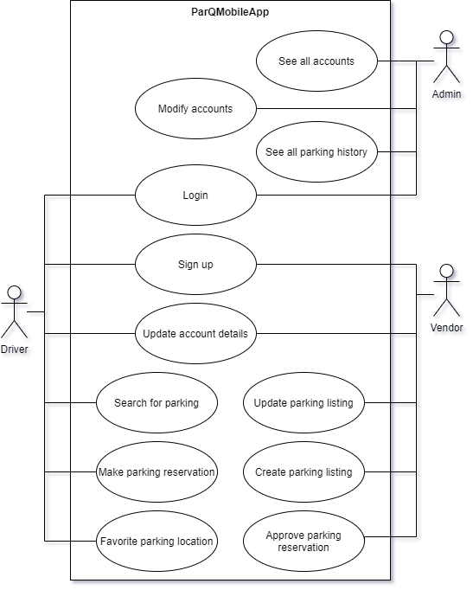

Use Case Diagram of React Native mobile application Version 1

### 1.0.2   Class Diagrams

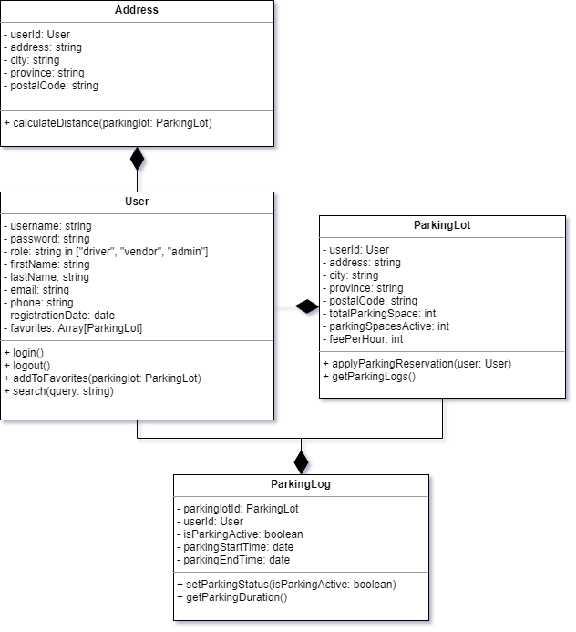

Class Diagram of React Native mobile application Version 1

### 1.0.3   Object Diagrams

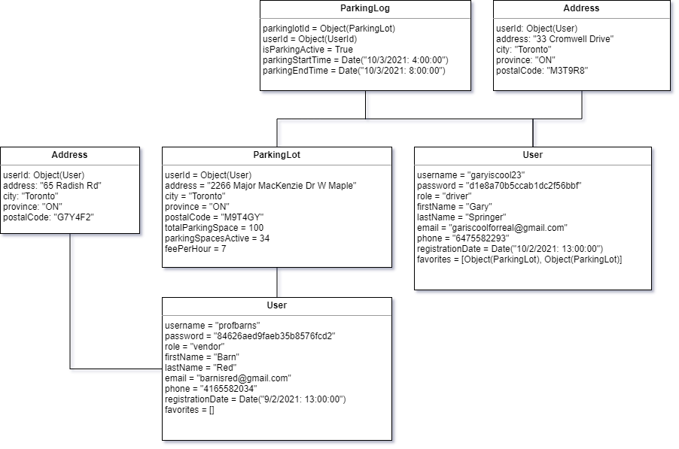

Object Diagram of React Native mobile application Version 1

### 1.0.4   Component Diagrams

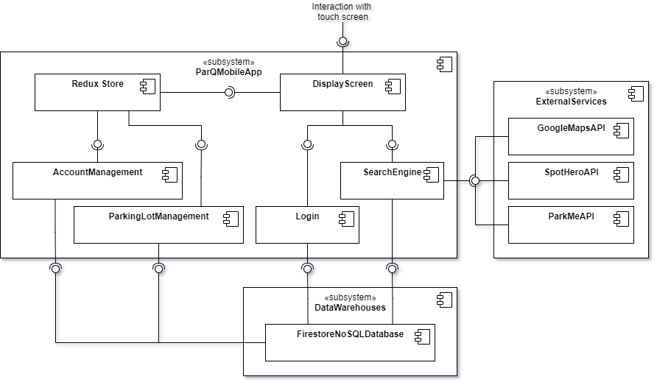

Component Diagram of React Native mobile application Version 1

### 1.0.5   Deployment Diagrams

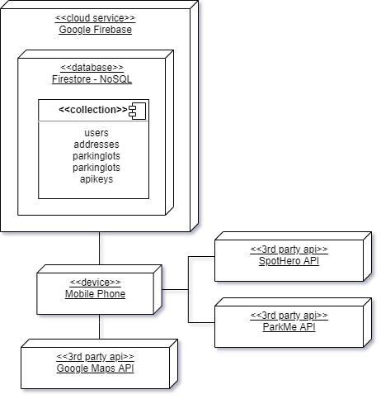

Deployment Diagram of React Native mobile application Version 1

### 1.0.6   Package Diagrams

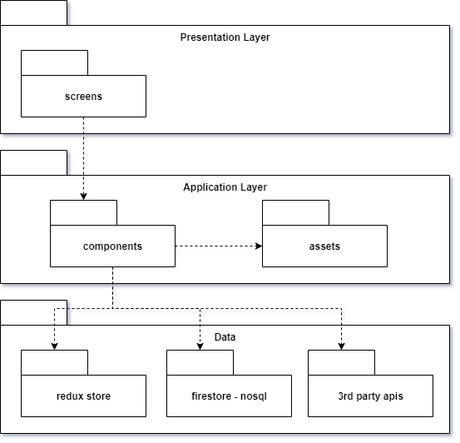

Package Diagram of React Native mobile application Version 1

### 1.0.7   Activity Diagrams

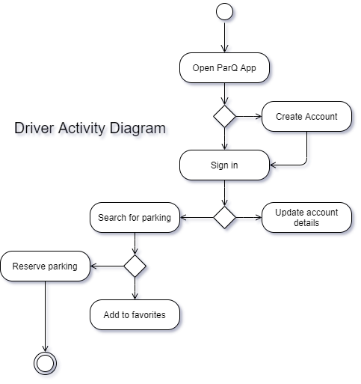

Activity Diagram for Driver role Version 1

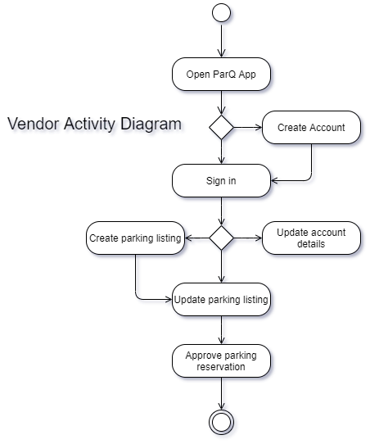

Activity Diagram for Vendor role Version 1

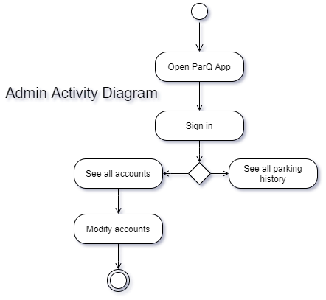

Activity Diagram for Admin role Version 1

### 1.0.8   Sequence Diagrams

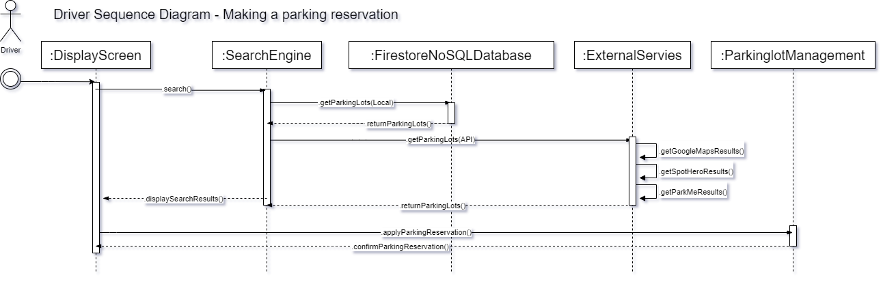

Driver Sequence Diagram for the use case of making a parking reservation Version 1

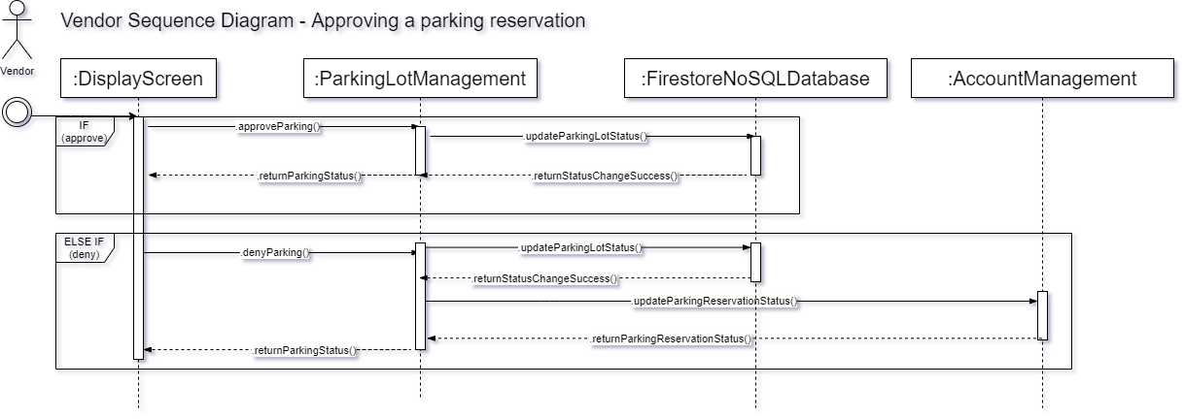

Vendor Sequence Diagram for the use case of making a parking reservation Version 1

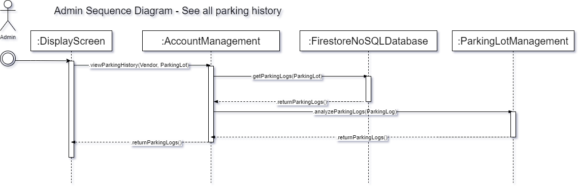

Admin Sequence Diagram for the use case of seeing all parking history Version 1

### 1.0.9   ERD Diagrams

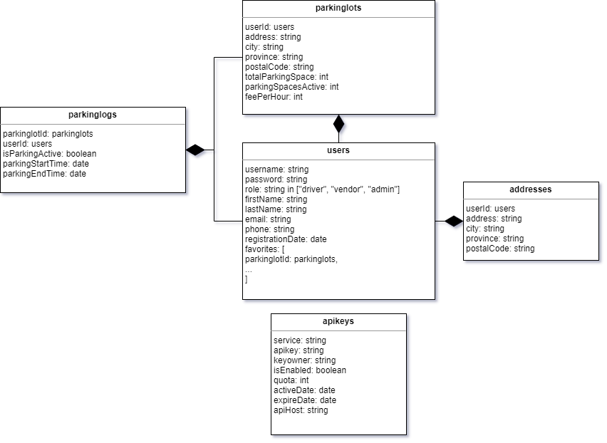

ERD Diagram of Google Firebase’s Firestore NoSQL database Version 1

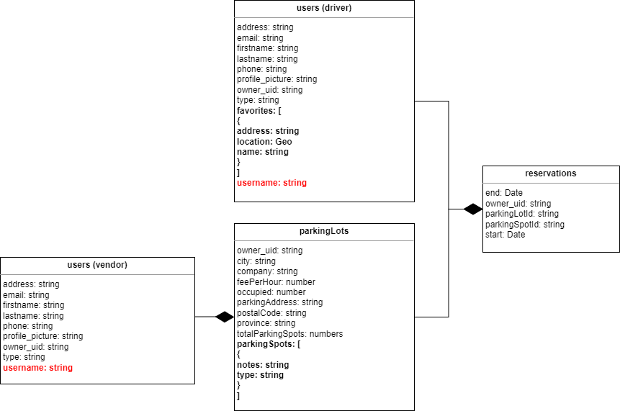

ERD Diagram of Google Firebase’s Firestore NoSQL database Version 2

# APPENDIX B (TEST PLAN)

## 1.0 Introduction

### 1.0.1   Goals

**Bug discovery:** The immediate goal of testing is to find errors at any stage of software development. More the bugs discovered at an early stage, the better will be the success rate of software testing.

**Quality:** Though quality depends on various factors, such as correctness, integrity, efficiency, etc., reliability is the major factor to achieve quality. The software should be passed through a rigorous reliability analysis to attain high-quality standards.

**Risk management:** Risk is the probability that undesirable events will occur in a system. These undesirable events will prevent the organization from successfully implementing its business initiatives.

**Customer satisfaction:** From the users perspective, the prime concern of testing is customer satisfaction only. Testing should be complete in the sense that it must satisfy the user for all the specified requirements mentioned in the user manual, as well as for the unspecified requirements, which are otherwise understood.

### 1.0.2   Assumptions

* The Test environment will be available by the start date given in the schedule for executing the test scripts, and sign-off has been forwarded to the Test Team Leader.
* The object code will be fully unit and integration tested and made available on the Test environment by the date(s) given in the schedule for executing the test scripts and sign-off has been forwarded to the Test Team Leader.
* The various specifications related to the Release will be the basis for testing the functionality of each release of ParQ SYSTEM. These documents will be available to the Test Team Leader by the start date given in the schedule for preparing test scripts for each release.
* Testing of non-English editions of ParQ SYSTEM will be executed by individuals who are able to read English, since the standards and requirements documents are written in English.

### 1.0.3   Risks And Assets

* Tight timelines.
* Undefined project scope.
* Insufficient resources.
* Continuously changing requirements.
* Natural disasters

## 2.0 Scope

### 2.0.1   Features To Be Tested

User Login function, Manage reservation function including extend, cancel and view, View map listing of expired, unpaid, open parking options function. Find expired/unpaid parking spaces near me function

### 2.0.2   Features Not To Be Tested

Administrator Login function, Officer Login function - Same functions with user login function.

## 3.0 Testing Procedures

Describe the testing procedures that the project will use. This includes the test lifecycle, types of testing, test objectives, and test criteria.

### 3.0.1   Test Objectives

* To increase the likelihood that the application intended for testing will work correctly under all circumstances.
* To increase the likelihood that the test application will meet all of the requirements described.
* Providing up-to-date information on the status of the product at the moment.

### 3.0.2   Types Of Testing

Describe the types of testing that the project will use.

#### 3.0.2.1   Unit Testing

A level of software testing where individual units / components of a software are tested. The purpose is to validate that each unit of the software performs as designed. Manage reservation functions including extend, cancel and view will undergo unit tests.

#### 

#### 3.0.2.2   Integration Testing

A level of software testing where individual units / components are combined and tested as a group. The purpose of this level of testing is to expose faults in the interaction between integrated units.

#### 3.0.2.3   Acceptance Testing

The customers, users and stakeholders will decide to approve the application/software or not.

#### 3.0.2.4   Stress Testing

* Application is under stress when user’s memory is lower than 2GB
* Application is under stress and gives error messages when users turn off their GPS system.
* Application is under stress with more than 100,000 concurrent users use the application.

#### 3.0.2.5   Performance Testing

Reservation functions have sufficient response time, stability, reliability, scalability and resource usage of a software application under normal workload.

Login functions have sufficient response time, stability, reliability, scalability and resource usage of a software application under normal workload.

View map listing functions have sufficient response time, stability, reliability, scalability and resource usage of a software application under normal workload.

Find expired/unpaid parking spaces near me functions have sufficient response time, stability, reliability, scalability and resource usage of a software application under normal workload.

### 3.0.3   Testing Tools

VS Code, JSMeter, Android Simulator.

# APPENDIX C (END-USER & ADMINISTRATOR MANUALS)

## 1.0 Driver/Vendor User Manual

### 1.0.1 Find/Reserve a Parking Lot

User downloads and open the app to see the home page

User clicks the map icon to open the search screen

When the lots are found, markers appear

When the marker is selected the parking info details appear and ask the user to reserve if they are logged in

### 1.0.2 Driver Sign in

Driver can login by clicking account icon from the home page

Sign in screen appears

If successful the account appears

### 1.0.3 Edit Driver Account Info

Driver can edit their information from the account screen by clicking the “Edit” button

The edit screen appears, and they can make changes

### 1.0.4 View Driver Parking History

Driver can view their parking history from the account screen by clicking the “History” button

The history/reservation page appears, and the driver can search for the one they desire

### 1.0.5 Vendor Sign in

Vendor can login by clicking account icon from the home page

Sign in screen appears

If successful the account appears

### 1.0.6 Edit Vendor Account

Vendor can edit their information from the account screen by clicking the “Edit Account” button

The edit screen appears

### 1.0.7 Vendor View/Edit Parking Lots

From the account page, the vendor can view the parking lots by clicking the “View Parking Lots” button

The list of parking lots appear, the vendor can click the edit icon to view the details of the parking lot

The edit parking lot page appears

### 1.0.8 Vendor Delete Parking Lots

From the account page, the vendor can view the parking lots by clicking the “View Parking Lots” button

The list of parking lots appear, the vendor can click the edit icon to view the details of the parking lot

A confirmation page appears

### 1.0.9 Vendor Add New Parking Lots

From the account page, the vendor can view the parking lots by clicking the “View Parking Lots” button

The list of parking lots appear, the vendor can click the “Add New Lot” button

The form to add new lot appears

### 1.0.10 Vendor View/Search Reservation History

From the account page, the vendor can view the parking lot reservations by clicking the “Reservation History” button

A list of reservations appears with a search option above the list

### 1.0.11 Register/ Sign up for a Driver Account

From the Home Screen, the driver can click the account button

The Sign in screen appears and the link to Sign up is clicked

The Sign Up page appears and the Driver Registration button is selected

The form loads to input the driver info

### 1.0.12 Register/ Sign up for a Vendor Account

From the Home Screen, the vendor can click the account button

The Sign in screen appears and the link to Sign up is clicked

The Sign Up page appears and Vendor Registration is selected

The form loads for vendor registration

## 2.0 Admin User Manual

### 2.0.1 Admin Sign in

The admin sign in page appears

On Success, the admin account page appears

### 2.0.2 Search, View, Edit or Delete Vendors

From the account page, the admin can select the “List of Vendors” buttons

Admin can search, view and delete vendors

### 2.0.3 Search and View Parking Lots Vendors

From the account page, the admin can select the “List of Vendors” buttons

Admin can search and/or view the parking lots

### 2.0.4 Search and View Parking Reservations

From the account page, the admin can select the “Reservation History” buttons

Admin can search and/or view the parking reservations

# APPENDIX D (PROGRESS MONITORING)

## 1.0 Progress Monitoring Release 1.0

|  | **Iteration I** | **Iteration 2** |
| --- | --- | --- |
| Story points at start of iteration | 107 | 107 |
| Completed during iteration | 0 | 21 |
| Changed estimates | 0 | 0 |
| Story points for new stories | 0 | 0 |
| **Story points at end of iteration** | **107** | **86** |

Note: Iteration 1’s time was entirely focused on understanding the tech stack that the team would be working with, specifically React Native and Firebase. Most of our team had limited knowledge in this tech stack, and along with other courses that team members had to deal with, had caused Iteration 1 to yield no change in story points. At the start of Iteration 2 the team has gotten enough knowledge about the tech stack to start completing stories and reducing the total number of story points that are left to be done for the ParQ mobile application.

#### 1.0.1 Burndown Chart

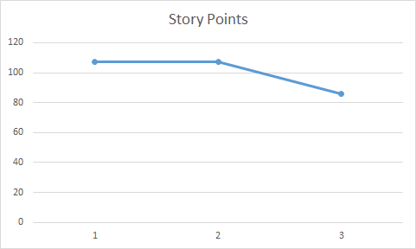

## 2.0 Progress Monitoring Release 2.0

|  | **Iteration I** | **Iteration 2** |
| --- | --- | --- |
| Story points at start of iteration | 118 | 118 |
| Completed during iteration | 0 | 118 |
| Changed estimates | 0 | 0 |
| Story points for new stories | 0 | 0 |
| **Story points at end of iteration** | **118** | **0** |

#### 1.0.1 Burndown Chart

